Installation of Python 3.11
Prerequisite: Uninstall Python 3.7(and any other older version) before installing Python 3.11, using the control panel to uninstall is fine.
Installation instructions
- Download the latest Windows Installer (64bit) for Python 3.11 from here: https://www.python.org/downloads/windows/
Direct Link : https://www.python.org/downloads/release/python-3110/
- Run the installation as ”Run as Administrator” (right-click on the installation file and select this option).
- Check ”Add python.exe to PATH”. Then, click “Customize Installation”. 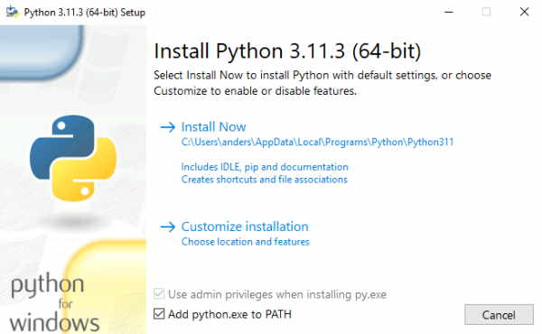
- Make sure that the following checkboxes are checked, then click “Next”. 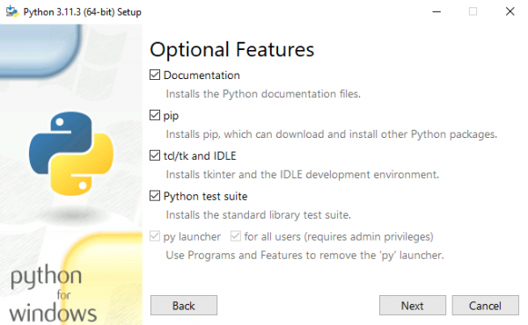
- Check “Install Python 3.11 for all users” and make sure that the checkboxes are checked. Then click “Install”. 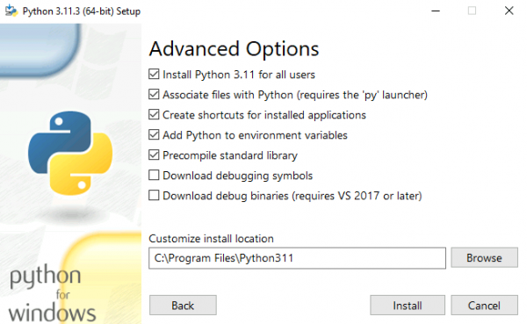

Make sure that Python 3.11 is in your path.
Open a normal cmd prompt , run the command
python --version or py –version

If successful, move to the project directory
Run command,
python setup.py
To launch the application
streamlit run app.py
Refer README.MD and QUICK START.md for any other information

